Name: __________________________________________

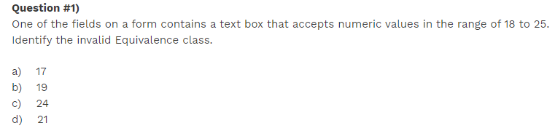

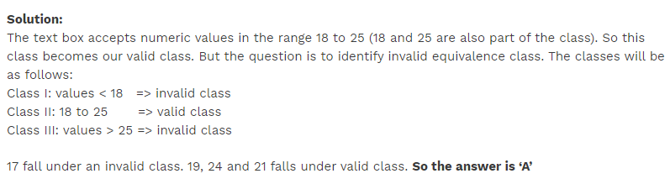

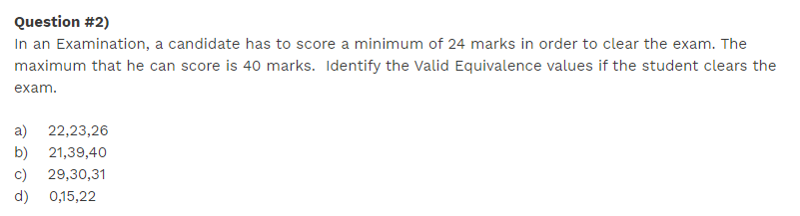

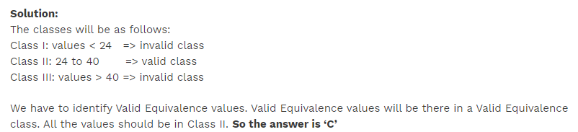

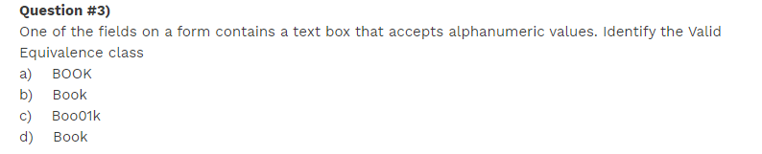

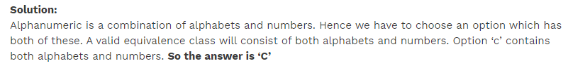

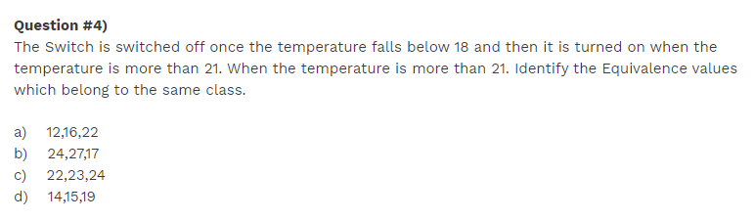

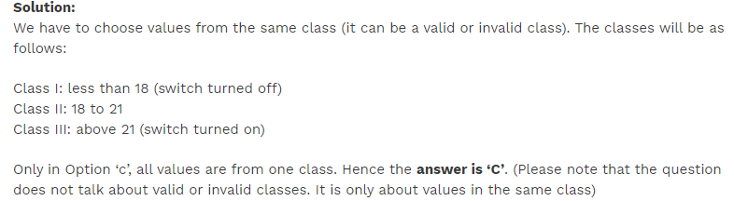

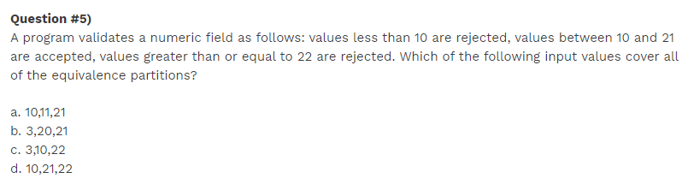

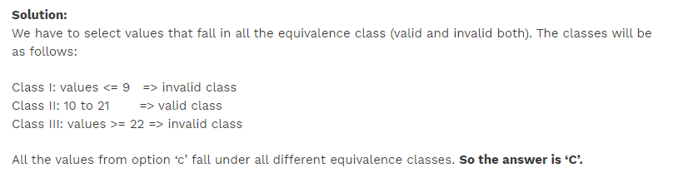

<https://www.softwaretestinghelp.com/istqb-exam-questions-equivalence-partitioning-boundary-value-analysis/>